Online Mentioning
mentioning status me restricted case or non restricted case sabhi ka mobile no show kar raha
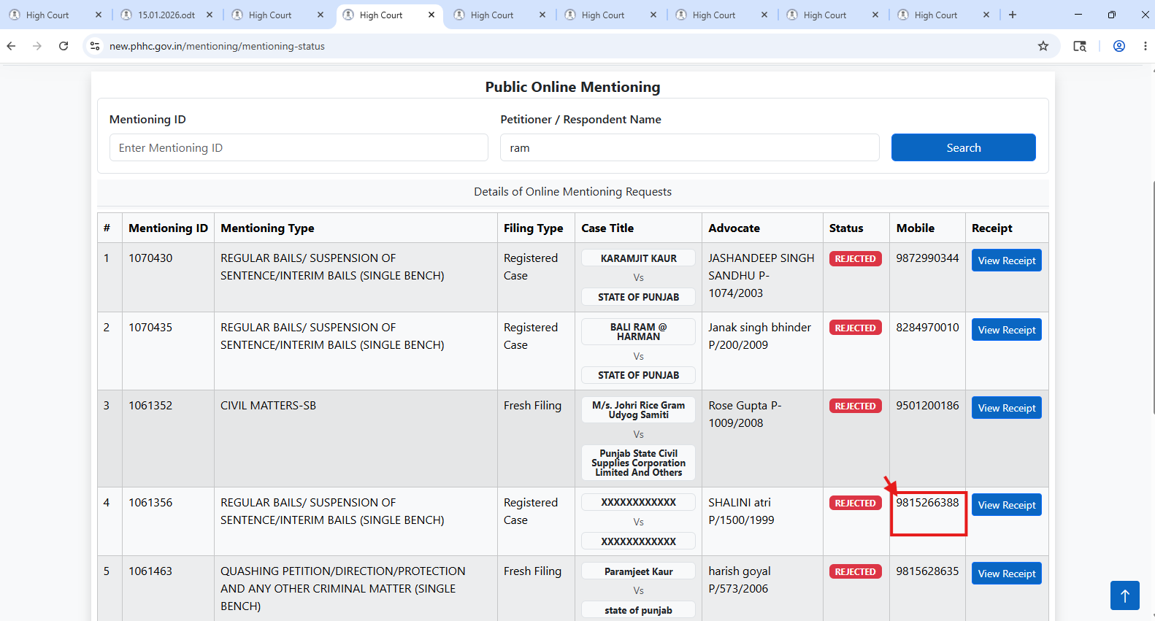
Active case or pending case sabhi ke view report per click karne per no record found ho raha hai
